Title: On some Investigations of the Organ of Corti, From the effects of Quinine and Quinidine on the Electrical Signature of Outer Hair Cells, To a Method to Prevent Cisplatin Ototoxicity, And the X-Ray Crystallography of Prestin and Finally a New Theory of the Physiological Basis of Electromotility

Abbreviated title: On some Investigations of the Organ of Corti

Authors: Jorge Enrique Delgado-Hachmeister, M.D., M.P.H, M.Sc., Ph.D.^{1,2}, Cindy Shope ⁵, Daniel Chelius³, M.D., John S. Oghalai⁴, M.D., Raye L. Alford, Ph.D.⁵, Bobby R. Alford†, M.D. ⁵, Brenda Farrell, Ph.D⁵, Lucy Handscomb, Ph.D.², Jonathan Ashmore, Ph.D.², Dan Jagger, Ph.D.², Issam Saliba, M.D.⁷, Thomas Lenarz, M.D.⁸, Sengoth Vilaysane, M.D.¹, Anat Shahar, Ph.D.⁶

Corresponding author:
1. Jorge E. Delgado-Hachmeister, M.D.
La Salle University
Mexican Faculty of Medicine
Islas Marianas No. 9, Fracc. Residencial Campestre Chiluca, Atizapán de Zaragoza, C.P. 52930, Edo. de Mex., México
Mobile: + 52 55 10 52 81 58
Home Phone: + 52 55 50 19 17 36
e-mail: jorgeenriquedelgadoh@hotmail.com
2. University College London, London, United Kingdom
3. Texas Children´s Hospital, Houston, TX, USA
4. Keck School of Medicine of the University of Southern California, California, USA
5. Baylor College of Medicine, Houston, TX, USA
6. David Ben Gurion University of the Negev, Beersheba, Israel
7. Université de Montreal, Québec, Canada
8. Technische Hochschule Hannover, Niedersachsen, Germany

Number of pages: 36

Number of figures: 9

Number of words: 5,511

Conflict of interest: The authors declare no competing financial interests.

Support of this study: This study was financed by a grant from the Fonds de Recherche
du Québec to Dr. Jorge E. Delgado-Hachmeister, a grant from Mexico of the National Council of Science and Technology (CONACYT) to Dr. Jorge E. Delgado-Hachmeister, and a grant from the National Institute of Deafness and Communication Disorders (NIDCD) to Dr. John S. Oghalai.

Abstract
While the actions of quinine on outer hair cell physiology of mammalians have been previously investigated, it remains unknown, the precise mechanism by which quinine induces reversible tinnitus and hearing loss. Also it is unknown why quinine produces in some rare cases irreversible hearing loss. Here we provide definitive evidence that quinine at therapeutic levels for the treatment of Falciparum malaria modifies outer hair cell physiology and electromotilty and also triggers apoptosis in outer hair cells. Here we provide definitive evidence that the main mechanism by which quinine modifies hearing thresholds is by modifying outer hair cell physiology, probably by interacting with prestin. We also found out that quinidine also modifies electromotility. Since quinine induces apoptosis of outer hair cells we suggest that in the clinical management of Falciparum malaria quinidine should be preferred. It has been also proven that quinidine might be more potent in the management of Falciparum malaria. Since it does not decrease Peak Capacitance and to the best of our knowledge it does not induce permanent hearing loss in some cases. We suggest that these modifications of electromotility are through direct interaction of these stereoisomers with prestin. Therefore at therapeutic concentrations of quinine to treat Falciparum malaria it might not be an apoptotic mechanism but rather an irreversible modification of prestin function, something that quinidine does not induce.

Key Words: outer hair cells, voltage at peak capacitance, electromotility, apoptosis, quinine, quinidine, amphipaths, cisplatin ototoxicity, X-Ray Crystallography of Prestin, prevention of cisplatin ototoxicity, a new theory of the physiological basis of electromotility

Introduction
Outer hair cells (OHCs) exhibit electromotility, a form of motility in which the OHC shortens and elongates at high frequencies. Probably faster than any other known human muscle. This cell motility is essential for the low hearing thresholds and remarkable frequency selectivity of the mammalian ear (Brownell, 1984;Brownell et al., 1985;Dallos et al., 1991;Ashmore, 1987;Ruggero and Rich, 1991) As well known the ear is an organ designed to amplify sound at all levels from the middle ear until the inner ear. Sound is already amplified in the middle ear, since the membrane ratio of the tympanic membrane is several times greater that then membrane that articulates the stapes at the oval window. Electromotility has been postulated to be a piezoelectric-like mechanism that operates within the OHC lateral wall plasma membrane and is tightly coupled to membrane polarization (Weitzel et al., 2003;Spector et al., 2003;Dong et al., 2002). However, we believe that the physiology of electromotility is much simpler than previously believed. We came to the conclusion that electromotility is a mechanism in which prestin functions as a channel (personal communication, Professor Jonathan Ashmore, University College London), and a capacitor. Since prestin is an anion exchanger the stoichiometry of membrane charge must be asymmetric, this means that anions that travel through the channel transports anions in a different charge symmetry on one side 1 or 2 or probably more. The involved anions to the best of our knowledge are Cl⁻ and HCO₃⁻, this suggest that pharmacological interventions that stimulate carbonic anhydrase would augment electromotility. So pharmacological strategies that stimulate carbonic anhydrase would improve hearing in hearing impaired individuals. Dr. Anat Shahar of David Ben Gurion University of the Negev carried out the X-Ray crystallography of prestin. (personal communication), in the methods section we described how this can be done. Also we came to the conclusion that by inhibiting electromotility cisplatin ototoxicity is reduced, since by abolishing electromotility this hampers the entrance of cisplatin into the outer hair cell and prevents apoptosis of OHC´s. (Personal communication, Dr. Lucy Handscomb, University College London, and Dr. Raye L. Alford & Dr. Bobby R. Alford, Baylor College of Medicine, Houston, TX, USA) Also in the method sections we described how this can be demonstrated. To abolish electromotility gadolinium was used, a lanthanide that inhibits electromotility reversibly. Also to inhibit electromotility at the stereocilia amiloride was used. But it has to be considered that neodymium might inhibit electromotility more effectively that gadolinium, neodymium is also a lanthanide. Taking into account our findings in our article that quinine and quinidine modify the electrical signature of OHC´s, we suggest that they act allosterically to modify prestin function. This is important because it suggests that OHC´s might possess endogenous biological molecules that regulate electromotility. So our hearing theory becomes more complex, than suggested by von Békésy. (Hachmeister JE, 2003) Not only the stiffness of the basilar membrane determines the remarkable frequency selectivity of the Organ of Corti, but also molecular mechanisms regulating electromotility. We also believe that when the capacity of the inner side of the membrane becomes negative, water is attracted into the inside and the OHC elongates. For this to happen aquaporin is fundamental, and it has been demonstrated that OHC´s present aquaporin in their cell membrane (Miyoshi et. al., 2017). The experiments to demonstrate this were carried out by Jagger et. al. (Personal communication, University College London). And when the outside of the membrane becomes positive water flows outward, shortening the cell. For this to happen the delicate arrangement of the subsurface cisternae is fundamental (Lei Song, Joseph Santos-Sacchi, 2015).
To the best of our knowledge OHCs are the only cells in the human body or also in other mammals that demonstrate nonlinear capacitance, a distinctive signature of OHCs that appears as a bell shaped curve when voltage is modified from negative to positive, and is particularly well demonstrated in the whole-cell capacitance electrophysiological mode. This nonlinear capacitance is considered the electrical signature of electromotility, meaning that it is of dramatical importance for elongation and shortening of the OHC to occur.
Amphipathic substances are both lipid and water soluble and are therefore able to interact with cell membranes. Interestingly, a variety of amphipaths are ototoxic (Deuticke, 1968). Ionic amphipaths can reduce electromotility by decreasing the magnitude of the non-linear capacitance and/or shifting the non-linear capacitance function along the voltage axis. For example, chlorpromazine (a cationic amphipath) shifts the non-linear capacitance function in the depolarizing direction (Lue et al., 2001), while salicylate (an anionic amphipath) both shifts the non-linear capacitance function and diminishes the magnitude of the non-linear capacitance (Kakehata & Santos-Sacchi, 1996), and induces reversible tinnitus and hearing loss, and is some cases irreversible hearing loss, so the surmounting evidence suggests that amphipaths that induce a reduction in Peak Capacitane might induce permanent hearing loss. So this might be the mechanism by which also quinine produces irreversible hearing loss, by modifying prestin function irreversibly. This is important since genetic manipulations that would induce prestin to be transcribed again and expressed de novo in the lateral membrane of OHC´s would produce a return of hearing. This might be important in other forms of hearing loss like presbyacusis.
Quinine is a cationic amphipath that also affects hearing (Hennebert and Fernandez, 1959). The ototoxicity of quinine has been attributed to its deleterious actions on different levels of the auditory system (Lin et al., 1998;Kenmochi and Eggermont, 1997;Puel et al., 1990;Lin et al., 1998). Quinine reduces frequency selectivity and otoacoustic emissions (Zheng et al., 2001). Consistent with an action on cochlear function, quinine induces ultrastructural changes in the OHC (Karlsson et al., 1991). It also affects OHC physiology such as inducing motile responses (Karlsson and Flock, 1990), blocking postsynaptic acetylcholine mediated Ca²⁺ activated K⁺ currents (Yamamoto et al., 1997), reducing electromotility (Dieler et al., 2002), and diminishing force generation (Jarboe and Hallworth, 1999). On the other hand isomeric amphipaths are of importance to infer a better physiological understanding of how prestin works. That is why in this paper we also include the actions of quinidine, an isomeric amphipath of quinine; (that can also be used for the treatment of Malaria, and not only that it might be more potent and more effective for the treatment of Falciparum malaria) (White N et. al., 1981), on the nonlinear capacitance of OHCs. However, not as detailed as for quinine, we therefore would like to apologize just for including data for quinidine at just one concentration. Time constraints did not let us to perform more experiments, neither to evaluate if quinidine induces apoptosis of OHCs. However, when using quinidine for the treatment of Falciparum malaria, the electrocardiograph has to be tightly monitored.
We hypothesized that quinine and quinidine may inhibit cochlear function in a manner similar to other ionic amphipaths. In particular by modifying prestin function. Thus, we sought to determine the effect of quinine and quinidine on the OHC nonlinear capacitance. Since this is an indirect marker of prestin physiology. Consistent with our hypothesis, we found that quinine shifted the OHC non-linear capacitance towards depolarized potentials with statistically significant changes in its magnitude. The shifts were fully reversible at low concentrations but only partially reversible at high concentrations. We also demonstrated that high concentrations of quinine led to OHC death. Indicating that when treating Falciparum malaria with quinine therapeutic levels should be tightly monitored. We further analyzed this finding by tracking changes in the whole cell input resistance and calculating membrane phospholipid transfer associated with apoptosis. Chlorpromazine, another ionic amphipath, was used as a control. All studies confirmed that high concentrations of quinine are associated with irreversible OHC damage, a finding probably not observed with quinidine. However, since salicylic acid also might induce permanent hearing loss we suggest that these irreversible hearing threshold changes might be by a permanent alteration of prestin function and not necessarily by induction of apoptosis of OHCs at therapeutic concentrations.

Materials and Methods

Electrophysiological Recordings from OHCs
Male or female albino guinea pigs were sacrificed by guillotine and their temporal bones were isolated. The bony labyrinth and stria vascularis were removed and the apical two turns of the organ of Corti dissected and treated with 0.5 mgml⁻¹ trypsin (Sigma, St. Louis, MO) for five minutes. OHCs were then gently dissociated from the organ of Corti with a one microliter syringe (Hamilton, Reno, NV) and transferred to a 35 mm glass bottom culture dish (MatTek Corporation, Ashland, MA). To measure capacitive currents in isolation, we used ionic blocking solutions. K⁺ currents were blocked with TEA, CoCl₂ and CsCl; Ca²⁺ currents were blocked with EGTA. The external solution contained (in mM): 100 NaCl, 20 TEA, 20 CsCl, 2 CoCl₂, 1.47 MgCl_{2,} and 10 HEPES. Quinine was added to the external solution in concentrations from 0.001 to 10 mM. Quinine (Q1878, Sigma, St. Louis, MO) was used for concentrations ranging from 0.001 to 5 mM and quinine hydrochloride (Q1125, Sigma, St. Louis, MO) was used for the 10 mM quinine solution because of its associated higher solubility in water. The external solutions were adjusted to a pH of 7.2 with CsOH and to an osmolality of 300 mOsmKg⁻¹ with glucose. The patch-pipette internal solution contained (in mM): 140 CsCl, 1 EGTA, 2 MgCl₂, and 10 HEPES. The internal solutions were adjusted to a pH of 7.2 with CsOH and to an osmolality of 300 mOsmKg⁻¹ with glucose.
OHCs were observed with an inverted stage microscope (Axiovert 135 TV, Zeiss, Germany). Fresh external solution was constantly perfused over the cells with a gravity driven system at a rate of 1 mlmin⁻¹. Complete solution exchange occurred within 2 to 3 minutes. Whole cell voltage clamp recordings were made with an amplifier (Axon 200B) connected via digital to analogue converter (Digidata 1200A Axon Instruments, Foster City, CA) to a computer. Borosilicate pipettes (Borosilicate glass capillaries TW100-4, World Precision Instruments, Sarasota, Fl) were pulled with a carbon dioxide laser puller (P-2000 Micropipette Puller, Sutter Instrument Company, Novato, CA). The resistance of the pipettes was 1.5 to 3.5 MΩ. After forming a seal of at least 1 GΩ, pipette capacitance was compensated with amplifier circuitry and the whole-cell mode was then established by applying negative pressure. OHCs were held at a membrane potential of -40 mV, and collapsed by applying additional negative pressure. Initial membrane resistances (Rm) ranged from 100-500 MΩ and series resistance (Rs) < 10 MΩ. OHCs were collapsed (Fig. 1) to reduce the effects of changes in turgor pressure on voltage at peak capacitance (V_{pkCm}) and peak capacitance (C_{mpk}) (Kakehata and Santos-Sacchi, 1995). Rs was not compensated with the amplifier and cell capacitance (linear) was not subtracted from the recordings.
Two types of protocols were used to examine the response of the OHCs in the whole-cell configuration: (1) tracking the V_{pkCm} and (2) measuring the non-linear capacitance with admittance techniques. In the case of quinidine just 1 concentration was used, 1mM, and the admittance technique was used and not the tracking of V_{pkCm}

Tracking the Voltage at Peak capacitance, (V_{pkCm})
V_{pkCm} was tracked with jClamp version 3.99.2 (SciSoft, New Haven, CT), by monitoring for the reversal of polarity of gating currents (Kakehata and Santos-Sacchi, 1995). The tracking technique employs a voltage stimulus protocol where equal but opposite polarity voltages (±P protocol, ± 40mV) are delivered to the cell and generated currents summed to extract nonlinear gating currents as originally developed to measure ionic channel gating charge (Armstrong and Bezanilla, 1973;Keynes and Rojas, 1974). When the holding voltage is more negative than V_{pkCm} the gating current consists of an initial upward transient current and a subsequent downward transient current. The opposite occurs for a holding potential more positive than the voltage at peak capacitance.
We perfused the OHCs with quinine or the control solution for a minimum period of five minutes to insure total solution exchange and then measured V_{pkCm} until it stabilized. The time required to reach steady state after total solution exchange was between 3 to 10 minutes. Afterwards, we perfused with drug free external solution until V_{pkCm} recovered. Recordings were stopped when either R_{s} >10 MΩ or R_{m} <50 MΩ.
The dose-response curve for the tracking of δV_{pkCm} was fitted to the Hill equation (Hill, 1910;Holford and Sheiner, 1981)
where δV_{pkCm} is the observed change in voltage at peak capacitance, V_{max} is the maximum change in voltage at peak capacitance, A is the quinine concentration, K_{D} represents the concentration of quinine [A] that induces 50% of the maximal δV_{pkCm} by a saturating concentration of quinine and H is the Hill coefficient (Fig. 4).

Measuring Non-Linear Capacitance with Admittance Techniques
The nonlinear capacitance of the OHC was also measured under different quinine concentrations with admittance analysis available in jClamp version 3.99.2. This method calculates the cell capacitance, membrane resistance and series resistance every 2.56 ms from the measured cell admittance. A two-sine wave voltage stimulus was delivered to a cell (sum of two 10 mV peak to peak sine waves at 390.625 and 781.3 Hz). The current was measured every 10 μs and Fast Fourier Transform (FFT) conducted every 256 samples. This current was first corrected for the inherent phase shifts of the amplifier {Barnett, 1997 5575 /id} and then the real and imaginary components of the admittance were determined by dividing the complex current by the complex voltage at each frequency. The values of the admittance were then used to calculate the cell parameters (Donnelly, 1994;Rohlicek and Rohlicek, 1993;Santos-Sacchi et al., 1998). To determine the voltage dependent capacitance a DC voltage ramp (-150 to +150 mV; duration of ramp 1s) was added to the dual frequency stimulus.
V_{pkCm} was determined by fitting the capacitance function with the first derivative of a two state Boltzmann function, it relates nonlinear charge to membrane voltage (Kakehata and Santos-Sacchi, 1995;Huang and Santos-Sacchi, 1993) by
where
and Q_{max} is maximum nonlinear charge moved, V_{pkCm} is voltage at peak capacitance, V_{m} is membrane potential, z is valence, C_{lin} is linear membrane capacitance, e is electron charge, k is Boltzmann’s constant, and T is absolute temperature.

Histology of HEK and OHC cells

HEK cells
Human Embryonic Kidney (HEK) cells were grown in medium based on Dulbecco’s modification of Eagle’s medium (DMEM) (Mediatech, Herndon, VA). It contained in 1 L: 100 mL of fetal bovine serum (Invitrogen, Life Technology, Carlsbad, CA); 17.8 mM NaHCO₃ and 15.8 mM HEPES dissolved in DMEM. HEK293 cell line was purchased from American Type Cell Culture (ATCC) (Manassa, VA). Frozen cells (1 ml at 10⁶ cells ml⁻¹) were suspended in 9 ml of DMEM solution and centrifuged for 5 minutes. The cell pellet was re-suspended in 10 ml of fresh media and plated in a 100 cm³ culture flask (Beckton Dickinson, Franklin Lakes, NJ). The flasks were placed in a water-jacketed CO₂ incubator (Nuaire, Plymouth, MN) and maintained at 37˚C in 5% CO₂. HEK cells adsorb to the polystyrene surface and are 90% confluent within a week. The cells were passed weekly. Briefly, the excess media was decanted from the flask and trypsin (2 ml at 10 mgml⁻¹ of EDTA) (Invitrogen Life Technology, Carlsbad, CA) was added, and cells incubated for 5 minutes. Then DMEM (8 ml) was added to terminate the hydrolysis. The concentration of cells was determined with a hemacytometer (Fisher Scientific, Hampton, NH) from an aliquot of the suspension. To pass the cells an aliquot of this suspension was added to a fresh flask containing 10 ml of DMEM and placed in the incubator at a concentration of 5 x 10⁴ cells ml⁻¹. For an experiment an aliquot of the same suspension (concentration of 1 x 10⁵ cells ml⁻¹) was plated onto wells and placed in the incubator at 37˚C for 12 to 18 hrs. The cells used in the experiments had gone through 10 to 15 passages.

HEK exposure to cationic amphipaths
Cells were plated onto a 24 well dish (Falcon, Becton Dickinson, NJ) and incubated for 1, 8, or 24 hours in DMEM with chlorpromazine (CPZ) (Sigma-Aldrich, St. Louis MO). The final concentration of CPZ in the wells ranged from 1 μM to 0.1 mM. As a control, 5 μl of water was added to the HEK cells in the wells. After incubation 0.4% trypan blue solution (T8154, Sigma-Aldrich, St. Loius MO) was added to make a final ratio of 1:1 (DMEM:trypan blue). After 5 minutes, the DMEM/trypan blue solution was gently removed and four random 20 X images of each well were obtained with an inverted microscope (Zeiss Axiovert 200) with camera attached (Photometrics water-cooled Quantix). Living and dead cells were manually counted based on the absence and presence (respectively) of trypan blue staining.
In a second series of experiments, cells were plated (96 well, Falcon, Becton Dickinson) and incubated for 1 or 24 hours in DMEM with amphipaths, CPZ (same concentration as above) or quinine (10 mM). Then the solution was gently replaced with 50 μL of annexin-binding buffer. The buffer contained (in mM):10 HEPES, 140 NaCl, 2.5 CaCl₂ and 10 μL annexin V (Alexa Fluor, A13203, Molecular Probes, lot # 80A1-1) at a osmolality of 300 mOsmKg⁻¹. After incubation for 15 minutes 60 μL of 0.4% trypan blue solution was added to each well. After a further 5 minutes the solution was gently removed and washed once with the annexin-binding buffer. Images from six random locations in each well were obtained. One image at each location was obtained with halogen-light illumination and another with a 100 W fluorescent light source with a red (590 nm) filter. Cells found in the image were manually counted where their viability was determined by the extent of trypan blue and fluorescent staining.

Time lapse photography of HEK cells exposed to cationic amphipaths
Two time lapse protocols were followed for imaging the response to cationic amphipaths, 0.1 mM CPZ or 10 mM quinine. In one a single 20X field was imaged every 5 minutes and at the end the cells were labeled with a viability marker. In the other protocol cationic amphipaths were added to 20 wells of a plate. Every 5 minutes an image of a section of a different well was obtained by halogen-illumination after which 10 μL of annexin V was added to that same well. The annexin was allowed to react for six minutes then the solution was gently replaced and images (halogen-illuminated and fluorescent) were obtained as described above.

OHC exposure to cationic amphipaths
OHCs were gently dissociated from the organ of Corti without the use of trypsin. The cells were incubated in 200 μL of external solution containing in mM: 142 NaCl, 5.37 KCl, 1.42 MgCl2, 2 CaCl2, 10 HEPES. The pH was adjusted to 7.2 using NaOH and the osmolality was adjusted to 300 mOsm kg⁻¹ by adding glucose. A cationic amphipath was added to bathing solution for a final concentration of either 5 mM quinine or 0.1 mM CPZ. As a control, OHCs were incubated in artificial perilymph (no cationic amphipath). After incubation for an hour, 33 μL of annexin V was gently added to the bathing solution, and allowed to react for 15 minutes. The unbound annexin V was then diluted by the addition of ~ 2 ml of the bathing media. OHCs were allowed to settle for 10 minutes. We photographed each OHC found within the glass bottomed 10 mm inner well of the incubation dish. One image was obtained with halogen-light illumination and another with fluorescent light source as described above.

Addendum
Since early Medical School I have been fascinated by mechanisms of hearing. Understanding the elegant proposals by von Békésy. In particular understanding outer hair cell physiology. As you recently demonstrated prestin seems to be an anion antiporter, that generates net negative charge in the process of transport. Whose gradient is driven by the depolarization of the outer hair cell, when K+ enters outer hair cells via the stereocilia. Since the cell body of an outer hair cell is surrounded by perilymph, in contrast to the stereocilia, K+ concentration is higher inside the cell and Na+ concentration higher in the bathing perilymph. However, apparently outer hair cells do not possess Na+/K+ ATPase.
https://en.wikipedia.org/wiki/Na%2B/K%2B-ATPase
https://quizlet.com/167858317/hair-cells-flash-cards/
So apparently outer hair cells maintain low potassium concentrations inside the cell. Which would be consistent with K+ depolarizing the cell, when the stereocilia are deflected. Especially as it is known that outer hair cells maintain a large electrochemical gradient between the endolymph and the intracellular space of the outer hair cell, apparently of 125mV. Whereas that between the cell body and the perilymph is of about 45mV and taking into consideration the endocochlear potential.
https://www.ncbi.nlm.nih.gov/books/NBK10867/
So when the outer hair cell is depolarized prestin must open and allowing for the exchange of anions. Driven by a smaller gradient as mentioned. But this net movement of charge by prestin makes it act as a capacitor. https://www.ncbi.nlm.nih.gov/pubmed/22890707
Actually I would suggest that the outer hair cell becomes negative again, therefore increasing capacitance. So I believe that the capacitance of the outer hair cell becomes negative when the cell elongates. This is consistent with outer hair cells becoming longer during hyperpolarization. https://www.sciencedirect.com/topics/biochemistry-genetics-and-molecular-biology/prestin
It should be mentioned also that water is a dipole. Because prestin by itself cannot drive electromotility. This becomes evident when one considers the delicate arrangement of the outer hair cell regarding its cytoplasm. https://www.sciencedirect.com/science/article/pii/S0006349514047547
It becomes clear that this delicate arrangement is of paramount importance for electromotility and has been confirmed in previous studies.
If one considers that outer hair cells act like an hydraulic system water entering the outer hair cell would drive electromotility. When water enters the cell, the cell would elongate during hyperpolarization and vice versa.
https://www.youtube.com/watch?v=YlmRa-9zDF8
https://www.worldofmolecules.com/solvents/water.htm
Since water is a dipole oxygen is relatively negative and hydrogen ions relatively positive. So probably the hydrogen ions of water would be attracted when the cell hyperpolarizes, causing water to enter at higher speeds and driving electromotility. I believe that this theory is corroborated by the recent identification of aquaporin 11 in outer hair cells.
https://www.researchgate.net/publication/311860512_Quantitative_Analysis_of_Aquaporin_Expression_Levels_during_the_Development_and_Maturation_of_the_Inner_Ear
https://en.wikipedia.org/wiki/Aquaporin
So I believe I present an interesting hypothesis, that needs to be confirmed through lab studies.
Method to do the X-Ray Crystallography of Prestin

Done by Dr. Anat Shahar, Ph.D., of David Ben Gurion University of the Negev

Ich habe auch eine Hypothese das Prestin mit Neodymium charakterisiert werden kann gearbeitet.

To the best of my knowledge prestin has never been crystallized. So I believe with neodynium it can be achieved. Since the isotope apparently binds with high affinity to prestin and also strongly inhibits electromotility, it is also a lanthanide like gadolinium.

You can Google for all that.

http://www.isotope.com/uploads/File/Protein_Prod_Flyer.pdf

With my sincere feelings of respect and love to you.

Methods to demonstrate the feasibility of preventing Cisplatin Ototoxicity
To understand what we also discussed in personal communications, please follow the links.
https://u.pcloud.link/publink/show?code=XZNLAQVZYTlBKIgDJKh2FiiRON0y9LqrN8y7
https://u.pcloud.link/publink/show?code=XZP4AQVZVoR6VT05H0ScAy0RqEX9GuykFsfX
https://u.pcloud.link/publink/show?code=XZ64AQVZj5otHfoa82Q2Jn2MSd4xduUSaGxV

Results

Quinine affects the non-linear capacitance function of OHC
As an example of the effect of quinine on OHC non-linear capacitance, we measured the voltage dependent capacitance in an isolated OHC perfused with 0, 0.1, 1.0, and 5.0 mM quinine (Figure 2). The voltage at the peak capacitance (V_{pkCm}) clearly shifted towards more positive membrane potentials with higher quinine concentrations. Quinine also caused a slight decrease in the magnitude of the non-linear capacitance, but this effect was variable.
The peak capacitance (C_{mpk}) of multiple OHCs measured at different quinine concentrations was averaged (Figure 3). There was not a generalized decrease of C_{mpk} with quinine concentration. Since we used quinine hydrochloride for the perfusion of OHCs at 10 mM, we tested if there where any significant differences between quinine and quinine hydrochloride at 1 and 5 mM concentration. We found that the pharmacological effects of quinine and quinine hydrochloride on the V_{pkCm} at 1 and 5 mM concentrations are not statistically different (P > 0.1, data not shown). The shift in the voltage at peak capacitance (V_{pkCm}) of multiple OHCs measured at different quinine concentrations was averaged (Figure 4). The V_{pkCm} shifted from –53.7 (± 1.7) to -54 (± 2.4), -51.3 (± 4.9), -45.7 (± 2), -20.7 (± 1.1), -7.5 (± 1.9), 8.9 (± 2.3), 22.8 (± 3.7) and 32.7 (± 4.4) mV (Mean ± S.E.M.), for solutions containing quinine at 0.001, 0.01, 0.1, 0.5, 1, 2, 5 and 10 mM, respectively. This data could be nicely fit with the Hill equation. The Hill coefficient was 0.94 (95% confidence interval (CI), 0.78–1.1), K_{D} was 1.05 mM (95% CI, 0.81-1.28), and V_{max} was 95.8 mV (95% CI, 87.6-104.1).
Interestingly, we found that the ability of V_{pkCm} to recover to its initial value after washout was a function of the quinine concentration that had been perfused (Figure 5). At low concentrations (< 5 mM), 90% of the OHCs recovered while at high concentrations (10 mM), only 20% recovered. So this might be the mechanism by which quinine induces permanent hearing loss in some cases, and also an apparent decrease in V_{pkCm.} We also observed that the whole-cell mode could be maintained much longer in OHCs perfused with low concentrations than with high concentrations of quinine. This finding was quantified by measuring the time it took for the input resistance to decline below 50 MΩ and plotted this as a function of quinine concentration (Figure 6). These data suggest that there are irreversible effects associated with high concentrations of quinine. In figure 7 we show the effects of 1mM quinidine concentration with an admittance technique, of interest is that at these relative high concentration changes were fully reversible and there was not an irreversible change in V_{pkCm,} we only observed an effect of changing V_{pkCm}, towards depolarized values towards the right, and these changes were fully reversible for a relative high concentration of quinidine of 1mM.

OHC exposure to cationic amphipaths
We tested for evidence of apoptosis using Annexin fluorescent labeling. Annexin binds phosphatidylserine lipids which are normally found only in the inner leaflet of the plasma membrane. Most healthy cells do not have fluorescence. Impending cell death causes phosphatidlylserine to flip into the outer leaflet of the membrane, and the cell will then become fluoresecent. Fluorescent images of a healthy OHC stained with annexin demonstrate labeling only in the apical part of the membrane, specifically the cilia and membrane up to the intercellular zonula adherens. Our studies confirm this finding and this staining pattern was observed in 89% of the 36 OHCs examined (Figure 7A). The other 11% was evenly divided between no labeling and labeling of the entire membrane. The reason annexin V labels the apical region is unknown, but perhaps this membrane domain is built different than other cells because it is exposed to endolymph with a concentration of K+ similar to intracellular levels.
When OHCs were immersed in high concentrations of quinine (5 mM ) we observed a very different labeling pattern (Figure 7B). Annexin now labeled multiple membranous structures within the cytoplasm as well as the entire plasma membrane. As a control, we also examined annexin labeling when OHCs were perfused with 0.1 mM chlorapromazine (CPZ). In this case, from a population of 27 cells, we found that 70% of the cells exhibited apical labeling (as in Fig. 7A) and 20% of the cells showed intracellular and plasma membrane annexin labeling (as in Fig. 7B). The remaining 10% of the cells demonstrated fluorescence over the entire plasma membrane, but no cytoplasmic labeling (Figure 7C). These results suggest that 5 mM quinine is more toxic to OHCs than 0.1 mM CPZ.
To verify the annexin results, we performed a similar experiment with cultured HEK. Time lapse photograph showed no initial annexing labeling at the onset of drug perfusion and for a short time after beginning perfusion (up to 5 minutes). However with time (up to 90 minutes), significant intracellular and plasma membrane labeling was noted for HEK cells exposed to either 10mM quinine or 0.1mM CPZ (Figures 7D and E). Control HEK cells did not demonstrate this finding. These data reveal that both drugs are toxic to both OHCs and HEK cells, and that this can be measured with annexin labeling studies.

Discussion
Our data suggest that low concentrations of quinine (< 1 mM) reversibly shift the OHC non-linear capacitance. Higher concentrations of quinine (> 1 mM) cause irreversible effects on OHC physiology. Importantly, there are changes in the OHC membrane suggestive of cell death. Intracellular staining with annexin is consistent with membrane poration, permitting annexin to enter the cell. Membrane poration is also consistent with the general decrease in membrane resistance with increasing quinine concentration observed during patch clamp experiments.
Quinine is a potassium-channel blocker and likely has multiple effects within the cochlea. Several groups have demonstrated that quinine reduces the endocochlear potential (EP) and therefore could affect cochlear function (Takeuchi et al., 2000;Takeuchi et al., 1996;Wang et al., 1993). However, the effect on the EP is dose dependent (Takeuchi et al., 2000) and in experiments in guinea pigs when the perilymphatic space was perfused with quinine at a concentration of 0.1 mM, there was no change in the EP (Puel et al., 1990). Despite this, there were significant reductions in the compound action potential, cochlear microphonics, and summating potential. In guinea pigs, 0.3 mM quinine reduces the EP from the control value of 85.7 ± 2.6 mV to 81.5 ± 3.0 mV, whereas 1mM quinine causes a large biphasic change of the EP (Takeuchi et al., 2000).
The therapeutic index for quinine in humans for the treatment of malaria is between 10 to 15 mg/l. This represents a quinine plasma concentration of 0.03 to 0.04 mM, a concentration of quinine that in mammals would have a minimal effect on the EP. In studies in humans in which therapeutic concentrations of quinine for the treatment of Plasmodium falciparum malaria have been used, hearing thresholds increased significantly at plasma concentrations of quinine of less than 5 μM and the maximum plasma concentration of quinine that was achieved was in the order of 20 μM. Hence, clinical quinine ototoxicity (i.e. at low concentrations) likely results from reversible changes in OHC electromotility. Other possible mechanisms for quinine ototoxicity include alterations in the excitability of spiral ganglion neurons (Lin et al., 1998) and/or modification of both voltage-dependent and acetylcholine mediated K⁺ currents of the OHC (Yamamoto et al., 1997;Lin et al., 1995). Recently it has been suggested that quinine may also modify inner hair cell function of the Organ of Corti.
Small changes in the feedback of the cochlear amplifier may have pronounced effects on basilar membrane mechanics, (Housley and Ashmore, 1991;Santos-Sacchi et al., 2001;Dolan et al., 1997;Kirk et al., 1997). OHCs exposed to micromolar concentrations of quinine would demonstrate a small shift in their electromotility transfer function that could be associated with hearing loss (Figure 8). At therapeutic plasma concentrations, quinine induces larger changes in V_{pkCm} (shifts from 1.4 to 3.5mV) than therapeutic concentrations of either CPZ or furosemide. This finding supports the argument that small changes in the feedback of the cochlear amplifier may have pronounced effects on basilar membrane mechanics (Dolan et al., 1997). To our knowledge, CPZ has never been reported to cause hearing loss or tinnitus in humans either at therapeutic or at overdose concentrations, yet CPZ is able to shift the V_{pkCm} at micromolar concentrations where neither quinine nor furosemide have an effect. Furosemide in therapeutic concentrations is not associated with a noticeable shift on the V_{pkCm}. This finding is consistent with the concept that the ototoxicity of furosemide is mediated by targeting the endocochlear potential (Ruggero and Rich, 1991) and not electromotility physiology (Santos-Sacchi et al., 2001).
Even though quinine’s ototoxicity is generally reversible it has been reported that quinine can be associated with irreversible increase of hearing thresholds in humans and other mammals. Acute and chronic quinine exposure in living guinea pigs causes dose-dependent OHC death (Hennebert and Fernandez, 1959). Our data are consistent with the hypothesis that high doses of quinine cause permanent hearing loss secondary to OHC damage, although a mechanism is unknown. Interestingly, irreversible ototoxicity is more common in patients who receive quinine but do not have severe Plasmodium falciparum malaria because there are less acute phase proteins in the serum for the quinine to bind to, creating an unusually high concentration of unbound, active quinine (Tange et al., 1997). This also supports the argument that the irreversible hearing loss associated with quinine is dose-dependent, and argues for the importance of monitoring serum levels of quinine to keep them within the therapeutic index.
Conclusion
We demonstrate that the principal mechanism by which quinine induces reversible hearing loss and tinnitus is by modifying outer hair cell function, and not related to the modification of the endocochlear potential as for example is the case with furosemide. Salicylates also produce a similar effect on electromotility. All these molecules we discuss in the present article are amphipaths and are able to partition into the outer hair cell membrane and modifying prestin function. The principal molecule mediating electromotility. This represents the first report detailed report as of today that describes that quinines mediated ototoxicity is mediated through a modification of outer hair cell function and electromotility. We also provide strong evidence that quinine can occasionally produce irreversible hearing loss by producing apoptosis of outer hair cells.
Figure Legends
Figure 1.
Photomicrographs of isolated OHCs in the whole-cell tight seal configuration. A. OHC immediately after going whole-cell. B. The same OHC in collapsed state. OHCs were collapsed by applying constant gentle negative pressure through a closed suction system with a syringe.
Figure 2.
Effects of different quinine concentrations on the shape of the nonlinear capacitance function of the OHC. The capacitance was obtained with the admittance protocol. The continuous lines represent the fit of the nonlinear capacitance curves to the first derivative of a two state Boltzmann function (Huang and Santos-Sacchi, 1993;Kakehata and Santos-Sacchi, 1995). The V_{pkCm} (mV), z, Q_{max} (pC) and C_{lin} (pF) obtained from the fit are (± S.E.M): control (●): -60.28 ± 0.08, 0.77 ± 0.002, 3.15 ± 0.01, 19.7 ± 0.04; 0.1 mM quinine (○):-48.81 ± 0.53, 0.66 ± 0.01, 3.04 ± 0.07, 19.5 ± 0.2; 1 mM quinine (): -11.03 ± 0.14, 0.62 ± 0.004, 2.68 ± 0.03, 20.2 ± 0.14; 5 mM quinine (△): 19.0 ± 0.3, 0.78 ± 0.01, 1.98 ± 0.03, 19.0 ± 0.1, respectively. Vm on the abscissa represents the membrane potential.
Figure 3.
C_{mpk} obtained with the tracking technique at different concentrations of quinine. Bars are mean S.E.M. With n = 3 to 14 (different cells) at each concentration of quinine. Only at 1 mM of quinine was there is a significant reduction of C_{mpk} relative to the control, 52.75 1.3 vs. 45.42 1.06, P=0.003 (two sample t-test) and P = 0.1 (one way analysis of variance).
Figure 4.
Effects of increasing concentrations of quinine on the VpkCm. Bars are mean ± S.E.M, n = 3 to 11 (different cells at each quinine concentration). Data is fit to the Hill equation:
Hill coefficient = 0.94 (95% CI, 0.78–1.1), KD = 1.05 mM (95% CI, 0.81-1.28) and
Vmax = 95.83 mV (95% CI, 87.6-104.1). Reference voltage at 0.001 mM quinine: -54
(+/- 2.4) mV.

Figure 5.
Recovery of V_{pkCm} is a function of quinine concentration. Values ± S.E for 4 to 12 different cells at each concentration. The values represent the proportion of OHCs that exhibited the same V_{pkCm} as the control after the quinine containing medium was replaced with normal external solution. The solid line is a fit of the data to an exponential decay function.
Figure 6.
Plot of recording time before the R_{m} ≤ 50 MΩ versus quinine concentration. Data is mean ± S.E.M., for 5 to 11 different cells at each concentration of quinine. The data were obtained with the tracking technique
Figure 7.
Effects of a 1mM quinidine concentrations on the shape of the nonlinear capacitance function of the OHC. The capacitance was obtained with the admittance protocol. The continuous lines represent the fit of the nonlinear capacitance curves to the first derivative of a two state Boltzmann function. Vm on the abscissa represents the membrane potential. We only observed a depolarization of V_{pkCm}, and these changes were fully resersible.

Figure 8.
Typical images of OHCs after immersion in external solution (A) or external solution with the amphipaths, quinine (5 mM) (B) or CPZ (0.1 mM) (C) added. The images were obtained after 1 hr of incubation. The images on the upper panel were obtained with halogen-light illumination, the lower panel with fluorescent light by use of the probe annexin-V. The images were obtained with 63X oil immersion objective. A. OHC with viable, healthy morphology (upper panel) where only the apical part of the cell is labeled with the fluorescent probe (lower panel). B. OHC in quinine showing visible deterioration of cell morphology (upper) annexin now labels multiple cytoplasmic components and the plasma membrane (lower panel). C. OHC in CPZ showing deterioration of cell morphology (upper) the plasma membrane is now labeled.
Figure 9.
Hill fits for voltage change of V_{pkCm} against concentration for chlorpromazine (CPZ), quinine and furosemide. Therapeutic index (TI) is the plasma concentration that is recommended for patients and the range is indicated by arrows for each drug. Data for CPZ is from Lue et al. (Lue et al., 2001) and for furosemide is from Santos-Sacchi et al. (Santos-Sacchi et al., 2001).

Figure 1A. 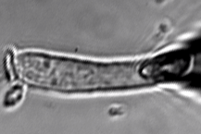

Figure 1B. 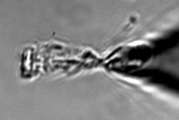

Figure 2. 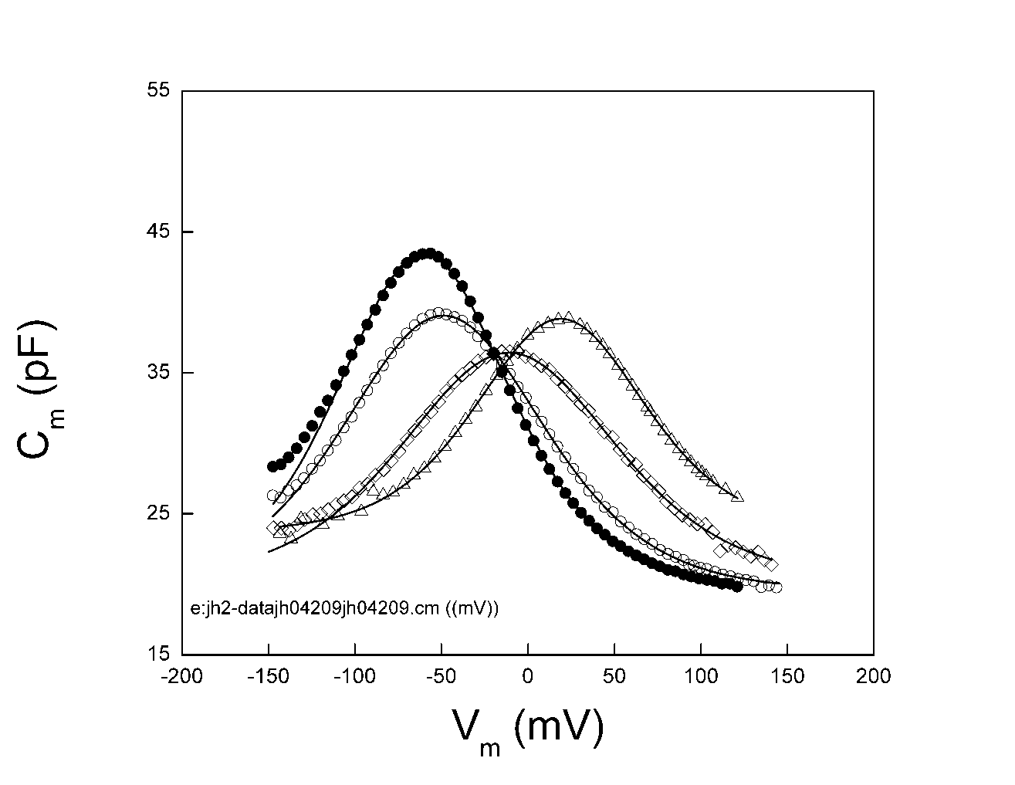

Figur 3. 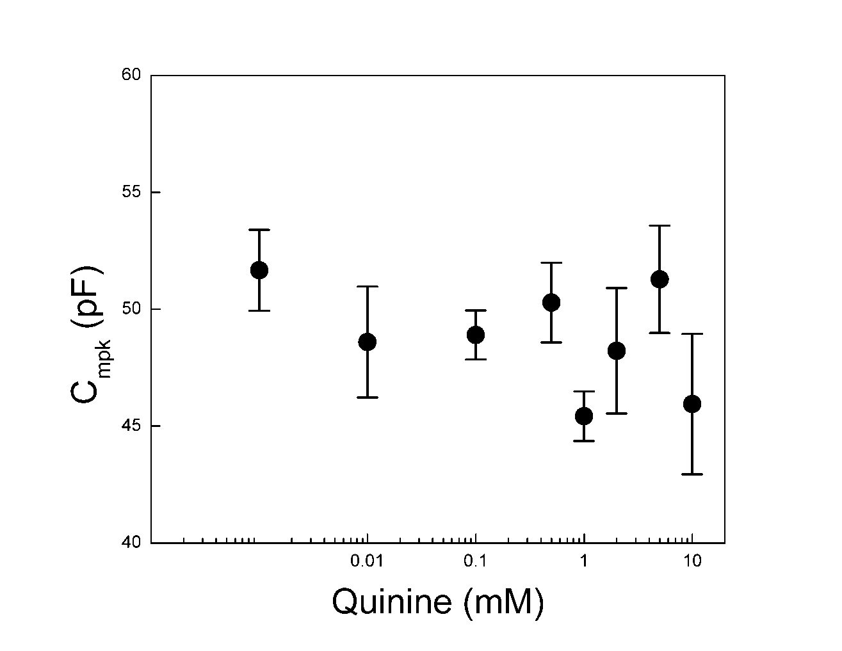

Figure 4.

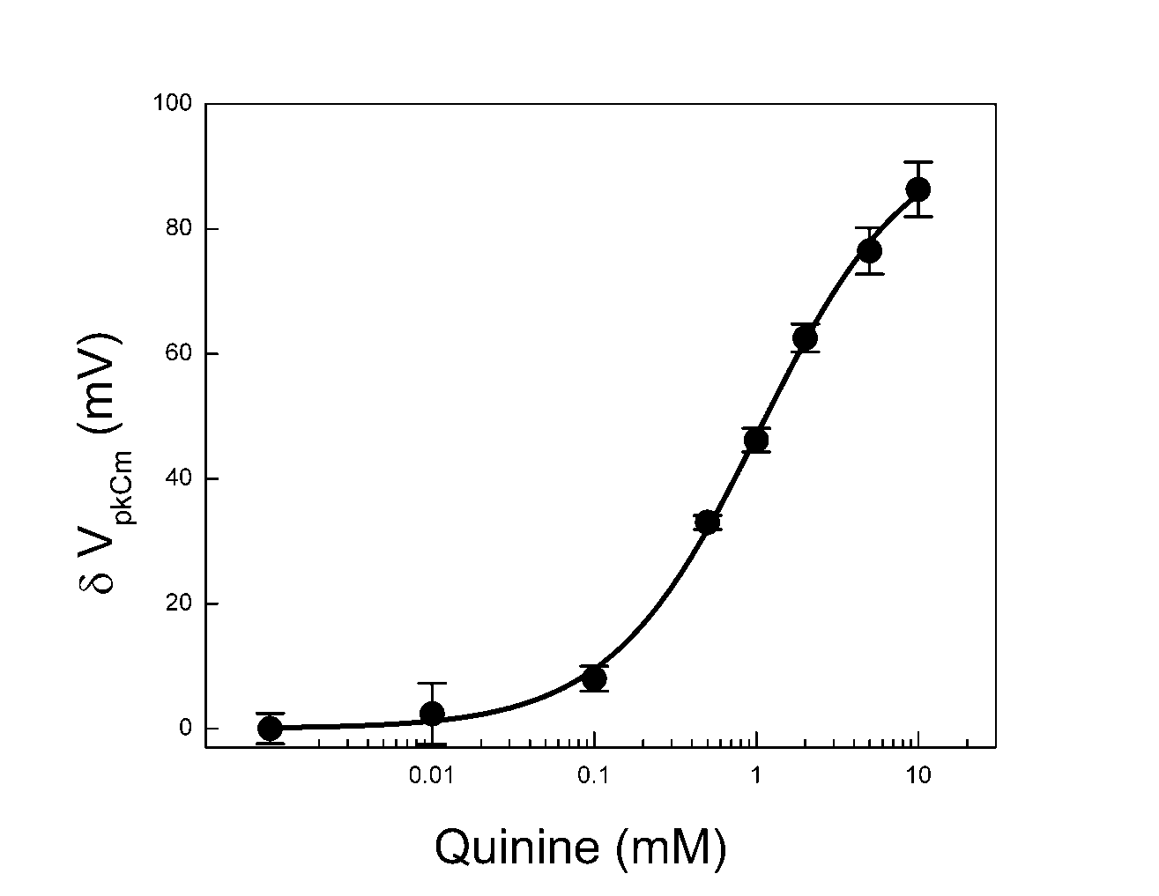

Figure 5.
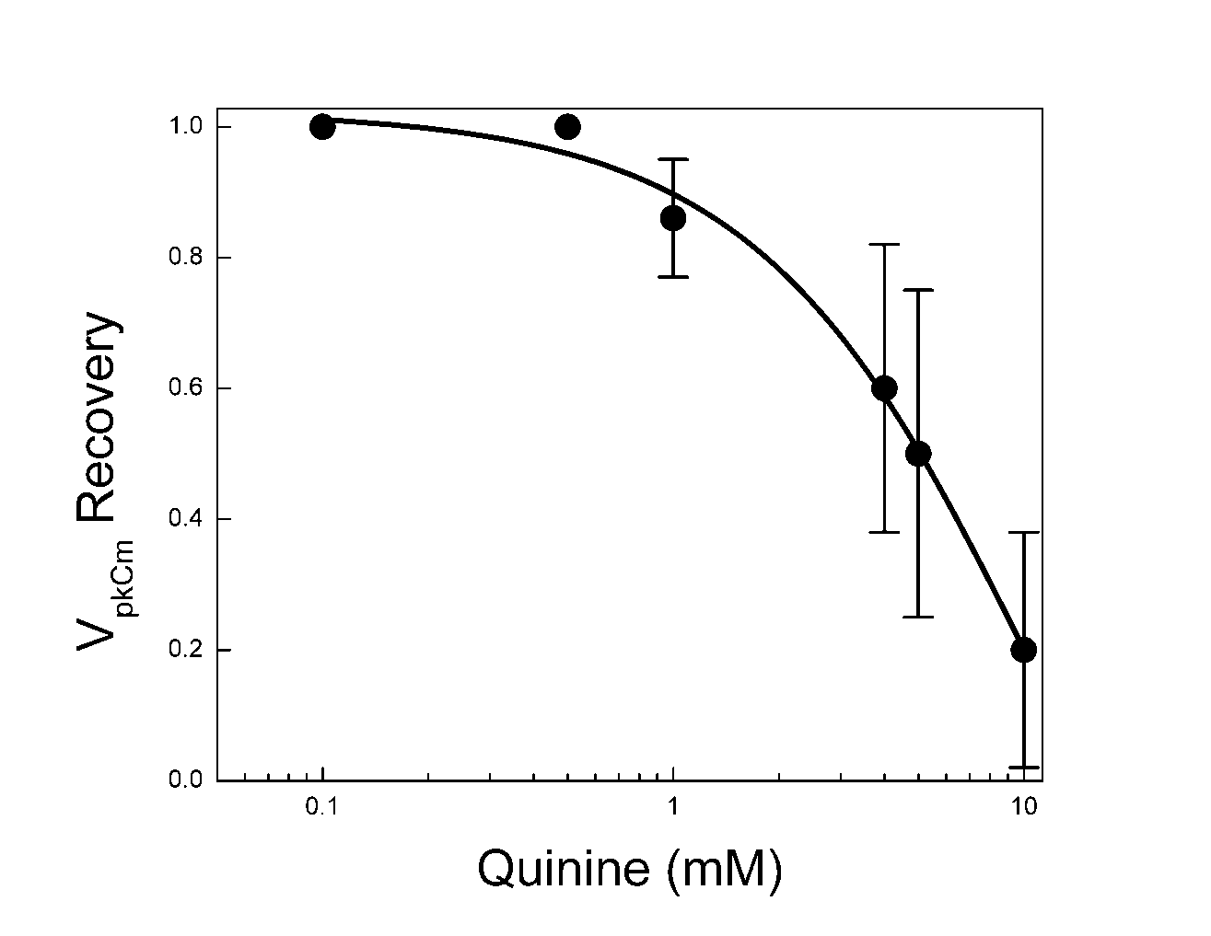

Figure 6.

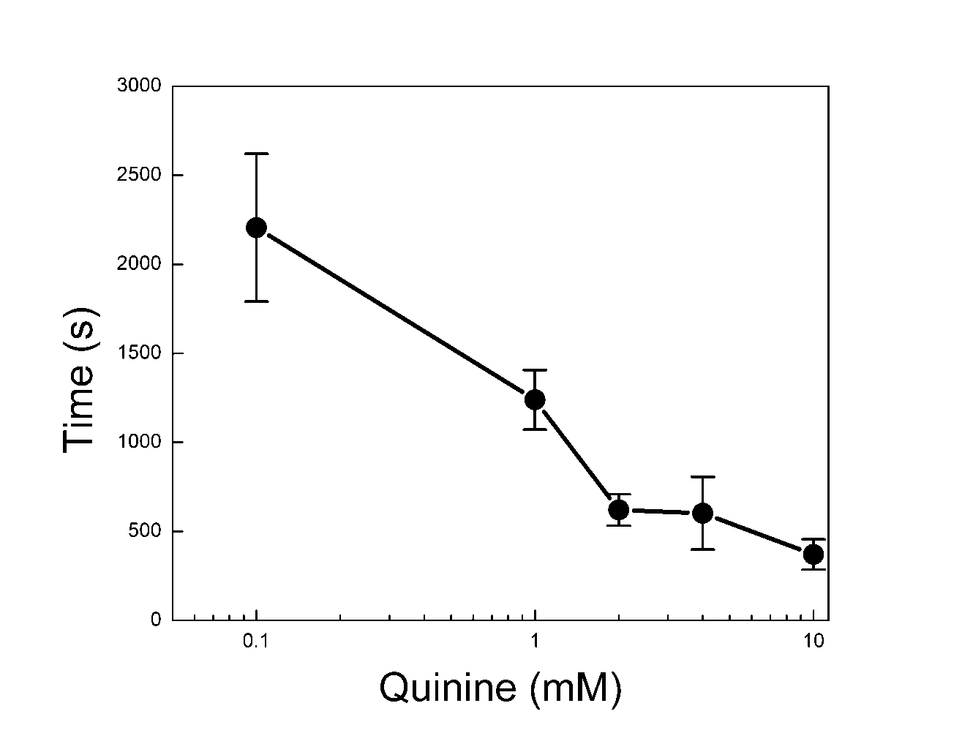

Figure 7.
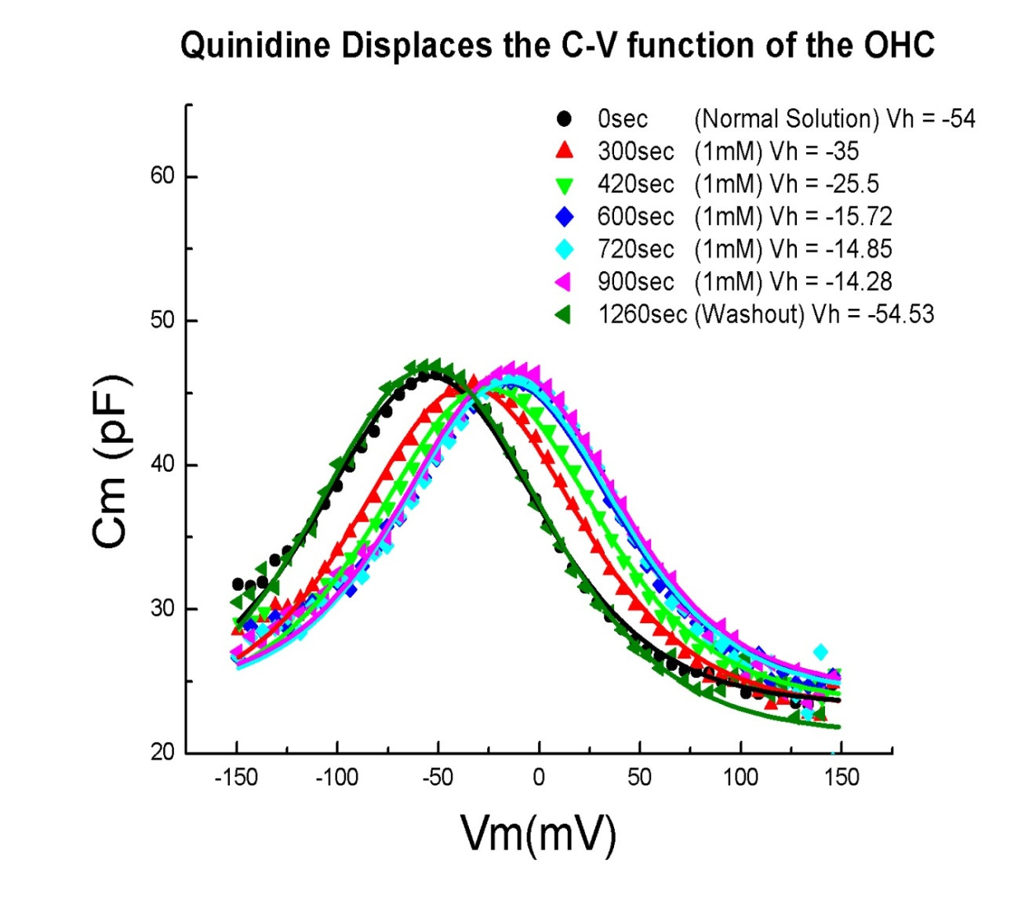

Figure 8.

A
B
C

Figure 9.

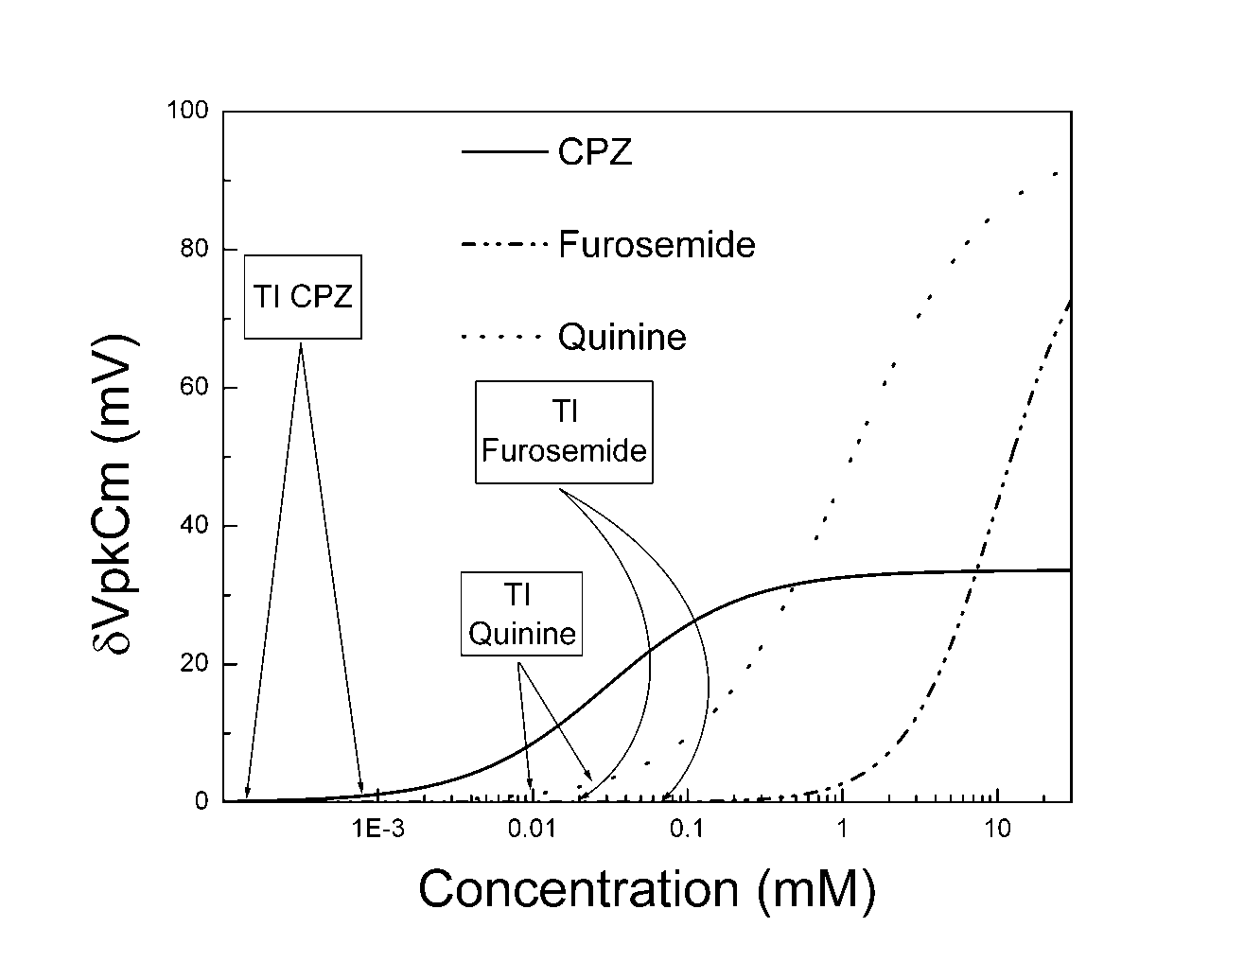

Reference List

Armstrong CM, Bezanilla F (1973) Currents related to movement of the gating particles of the sodium channels. Nature 242:459-461.
Ashmore JF (1987) A fast motile response in guinea-pig outer hair cells: the cellular basis of the cochlear amplifier. J Physiol 388:323-347.
Brownell WE (1984) Microscopic observation of cochlear hair cell motility. Scan Electron Microsc1401-1406.
Brownell WE, Bader CR, Bertrand D, de Ribaupierre Y (1985) Evoked mechanical responses of isolated cochlear outer hair cells. Science 227:194-196.
Dallos P, Evans BN, Hallworth R (1991) Nature of the motor element in electrokinetic shape changes of cochlear outer hair cells. Nature 350:155-157.
Deuticke B (1968) Transformation and restoration of biconcave shape of human erythrocytes induced by amphiphilic agents and changes of ionic environment. Biochim Biophys Acta 163:494-500.
Dieler R, Davies C, Shehata-Dieler WE (2002) [The effects of quinine on active motile responses and fine structure of isolated outer hair cells from the Guinea pig cochlea]. Laryngorhinootologie 81:196-203.
Dolan DF, Guo MH, Nuttall AL (1997) Frequency-dependent enhancement of basilar membrane velocity during olivocochlear bundle stimulation. J Acoust Soc Am 102:3587-3596.
Dong XX, Ospeck M, Iwasa KH (2002) Piezoelectric reciprocal relationship of the membrane motor in the cochlear outer hair cell. Biophys J 82:1254-1259.
Donnelly DF (1994) A novel method for rapid measurement of membrane resistance, capacitance, and access resistance. Biophys J 66:873-877.
Hachmeister JE. An abbreviated history of the ear: from Renaissance to present. Yale J Biol Med. 2003;76(2):81-6.
Hennebert D, Fernandez C (1959) Ototoxicity of quinine in experimental animals. Arch Otolaryngol 70:321-333.
Hill AV (1910) The possible effects of the aggregation of the molecules of haemoglobin on its dissociation curves. J Physiol 40:iv-vii.
Holford NH, Sheiner LB (1981) Understanding the dose-effect relationship: clinical application of pharmacokinetic-pharmacodynamic models. Clin Pharmacokinet 6:429-453.
Housley GD, Ashmore JF (1991) Direct measurement of the action of acetylcholine on isolated outer hair cells of the guinea pig cochlea. Proc R Soc Lond B Biol Sci 244:161-167.
Huang G, Santos-Sacchi J (1993) Mapping the distribution of the outer hair cell motility voltage sensor by electrical amputation. Biophys J 65:2228-2236.
Jarboe JK, Hallworth R (1999) The effect of quinine on outer hair cell shape, compliance and force. Hear Res 132:43-50.
Kakehata S, Santos-Sacchi J (1995) Membrane tension directly shifts voltage dependence of outer hair cell motility and associated gating charge. Biophys J 68:2190-2197.
Karlsson KK, Flock A (1990) Quinine causes isolated outer hair cells to change length. Neurosci Lett 116:101-105.
Karlsson KK, Flock B, Flock A (1991) Ultrastructural changes in the outer hair cells of the guinea pig cochlea after exposure to quinine. Acta Otolaryngol 111:500-505.
Kenmochi M, Eggermont JJ (1997) Salicylate and quinine affect the central nervous system. Hear Res 113:110-116.
Keynes RD, Rojas E (1974) Kinetics and steady-state properties of the charged system controlling sodium conductance in the squid giant axon. J Physiol 239:393-434.
Kirk DL, Moleirinho A, Patuzzi RB (1997) Microphonic and DPOAE measurements suggest a micromechanical mechanism for the 'bounce' phenomenon following low-frequency tones. Hear Res 112:69-86.
Lei Song, Joseph Santos-Sacchi, An Electrical Inspection of the Subsurface Cisternae of the Outer Hair Cell, Biophysical Journal, Volume 108, Issue 3, 2015, Pages 568-577, ISSN 0006-3495, https://doi.org/10.1016/j.bpj.2014.12.010.
Lin X, Chen S, Tee D (1998) Effects of quinine on the excitability and voltage-dependent currents of isolated spiral ganglion neurons in culture. J Neurophysiol 79:2503-2512.
Lin X, Hume RI, Nuttall AL (1995) Dihydropyridines and verapamil inhibit voltage-dependent K+ current in isolated outer hair cells of the guinea pig. Hear Res 88:36-46.
Lue AJ, Zhao HB, Brownell WE (2001) Chlorpromazine alters outer hair cell electromotility. Otolaryngol Head Neck Surg 125:71-76.
Miyoshi, T., Yamaguchi, T., Ogita, K. et al. Quantitative Analysis of Aquaporin Expression Levels during the Development and Maturation of the Inner Ear. JARO 18, 247–261 (2017). https://doi.org/10.1007/s10162-016-0607-3
Puel JL, Bobbin RP, Fallon M (1990) Salicylate, mefenamate, meclofenamate, and quinine on cochlear potentials. Otolaryngol Head Neck Surg 102:66-73.
Rohlicek V, Rohlicek J (1993) Measurement of Membrane Capacitance and Resistance of Single Cells Using Two Frequencies. Physiol Res 42:423-428.
Ruggero MA, Rich NC (1991) Furosemide alters organ of corti mechanics: evidence for feedback of outer hair cells upon the basilar membrane. J Neurosci 11:1057-1067.
Santos-Sacchi J, Kakehata S, Takahashi S (1998) Effects of membrane potential on the voltage dependence of motility-related charge in outer hair cells of the guinea-pig. J Physiol 510 ( Pt 1):225-235.
Santos-Sacchi J, Wu M, Kakehata S (2001) Furosemide alters nonlinear capacitance in isolated outer hair cells. Hear Res 159:69-73.
Spector AA, Brownell WE, Popel AS (2003) Effect of outer hair cell piezoelectricity on high-frequency receptor potentials. J Acoust Soc Am 113:453-461.
Takeuchi S, Ando M, Kakigi A (2000) Mechanism generating endocochlear potential: role played by intermediate cells in stria vascularis. Biophys J 79:2572-2582.
Takeuchi S, Kakigi A, Takeda T, Saito H, Irimajiri A (1996) Intravascularly applied K(+)-channel blockers suppress differently the positive endocochlear potential maintained by vascular perfusion. Hear Res 101:181-185.
Tange RA, Dreschler WA, Claessen FA, Perenboom RM (1997) Ototoxic reactions of quinine in healthy persons and patients with Plasmodium falciparum infection. Auris Nasus Larynx 24:131-136.
Wang J, Li QH, Dong WJ, Chen JS (1993) Effects of K(+)-channel blockers on cochlear potentials in the guinea pig. Hear Res 68:152-158.
White NJ, Looareesuwan S, Warrell DA, Chongsuphajaisiddhi T, Bunnag D, Harinasuta T. Quinidine in falciparum malaria. Lancet. 1981 Nov 14;2(8255):1069-71. doi: 10.1016/s0140-6736(81)91275-7. PMID: 6118523.
Weitzel EK, Tasker R, Brownell WE (2003) Outer hair cell piezoelectricity: frequency response enhancement and resonance behavior. J Acoust Soc Am 114:1462-1466.
Yamamoto T, Kakehata S, Yamada T, Saito T, Saito H, Akaike N (1997) Effects of potassium channel blockers on the acetylcholine-induced currents in dissociated outer hair cells of guinea pig cochlea. Neurosci Lett 236:79-82.
Zheng J, Ren T, Parthasarathi A, Nuttall AL (2001) Quinine-induced alterations of electrically evoked otoacoustic emissions and cochlear potentials in guinea pigs. Hear Res 154:124-134.

