Figure 3. Effects of Supplemental Audio Interventions on A1c by Baseline A1c
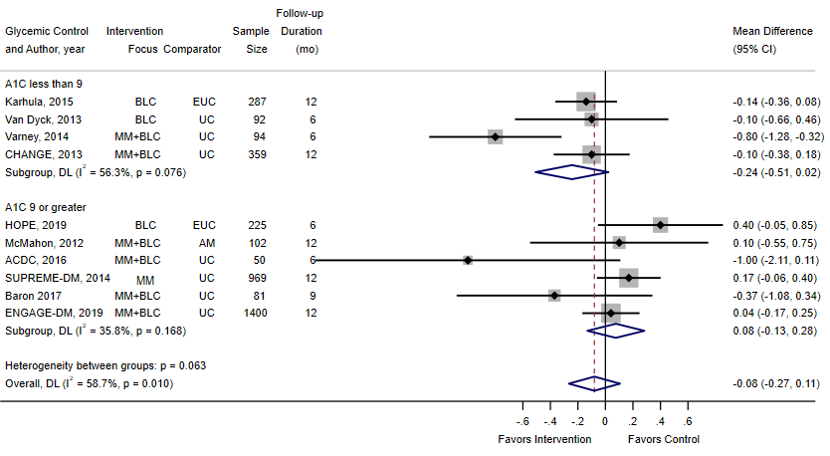
Abbreviations: AM, asynchronous messaging; BLC, behavioral/lifestyle counseling; EUC, enhanced usual care; MM, medication management; UC, usual care.

